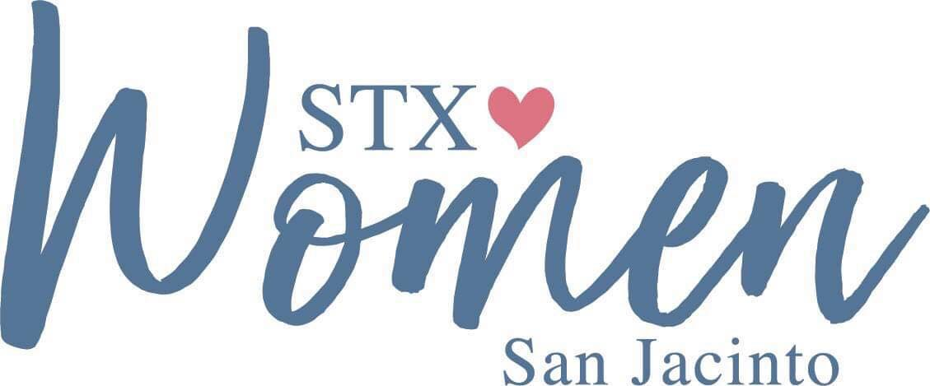

July 12, 2022

2 BY 2 – STX WOMEN SAN JACINTO PRAYING FOR SCHOOLS, TEACHERS AND STUDENTS
Begins Saturday, August 13, 2022

We will all grab a friend, family member or child and head to a local school, daycare, or university campus and pray together, 2 BY 2, on Saturday August 13, 2022 at 10 a.m.

We will also begin a 30-day prayer emphasis for all of our schools, teachers and students – I’ve attached a suggested prayer guide for you to use to continue covering our schools with our prayers.
Jesus is our faithful Lord. We know that He inclines our ear to hear us and that if two or three are gathered in His Name, He is there in the midst of them.
I am excited to call our women to the place of prayer as the new school year begins fall 2022.

Blessings to each of you as you step out to pray,
San Jacinto Section, STX Women:
Diane Jones

